

Capstone Project Report
Report 4 – Software Design Document

– Hanoi, August 2019 –

Table of Contents
I. Record of Changes 3
II. Software Design Document 4
1. System Design 4
1.1 System Architecture 4
1.2 Package Diagram 6
2. Database Design 8
2.1 Database Overview & Physical Architecture 8
2.2 Entity Relationship Diagram (ERD) 9
2.3 Detailed Table Descriptions 11
3. Detailed Design 15
3.1 Problem Ingestion & Dual-Core Simulation Engine (FE-01, FE-02, FE-03, FE-04) 15
3.2 Interactive Classroom Player & Assessment Engine (FE-05, FE-07, FE-08) 19
3.3 Multi-Tenant Governance, Moderation & Simulation Export (FE-06, FE-09, FE-10) 25

I. Record of Changes
Date | A*  M, D | In charge | Change Description
15/09/2026 | A | VietNHB | Initialized SDD baseline structure, architectural pattern selection, and preliminary subsystem definitions.
28/09/2026 | M | MinhTB | Formulated Dual-Solver simulation engine architecture, analytical Runge-Kutta 4th order (RK4) integration, and Matter.js bridge.
08/10/2026 | M | HungNT | Designed React 19 Single Page Application (SPA) package hierarchy, Pixi.js 2D canvas rendering pipeline, and 3-pane studio components.
16/10/2026 | M | KietVTT | Structured multi-tenant school isolation architecture, PostgreSQL Row-Level Security (RLS) policies, and 7-role RBAC security filters.
20/10/2026 | M | HungNT | Integrated anti-cheat pseudo-random parameter generator (PRNG), 3-tier account suspension lifecycle, and appeal workflow packages.
24/10/2026 | M | All Members | Finalized Stage 1 SDD: Completed multi-tier system architecture, subsystem integration topologies, and detailed backend/frontend package diagrams.
28/10/2026 | M | HungNT | Refined Detailed Design: Replaced DiscrepancyValidator with PhysicsLawValidator and updated SD-02 to Physics Law Verification Loop per Supervisor review.
*A - Added M - Modified D - Deleted

II. Software Design Document

1. System Design

1.1 System Architecture

1.1.1 Architectural Pattern & Philosophy
The PhysLive platform is architected around a 4-Tier Layered Architecture (Client-Server Modular Monolith with Cloud Microservices Integration). This pattern combines the operational simplicity, high transaction throughput, and transactional consistency of a Spring Boot modular monolith with the scalability of cloud AI services and high-performance client-side WebGL canvas rendering.

The system is organized into four distinct horizontal tiers and one cross-cutting infrastructure plane:

- Client Presentation Tier (Browser SPA): Built with React 19, Vite 7, Pixi.js v8, and Matter.js v0.19. Executes completely inside the user's web browser, offloading 2D kinematic calculations and interactive rendering from the backend server to achieve 60 FPS performance.
- Security & API Gateway Tier: Managed by Spring Security 6.x within the application container. Enforces stateless JWT authentication, CORS policies, rate limiting, and Role-Based Access Control (RBAC) across 7 distinct roles (GUEST, STUDENT, STAFF, SCHOOL, REVIEWER, MANAGER, ADMIN).
- Application & Domain Service Tier (Modular Core): Implemented in Java 21 using Spring Boot 3.3.4. Logically segregated into domain-driven modules (account, problem, physics, simulation, assignment, curriculum, library, support, operations). Communication between modules occurs through well-defined service interfaces and strongly-typed Data Transfer Objects (DTOs).
- Data Persistence & Computational Tier: Relational persistence powered by managed PostgreSQL 15 on Supabase, featuring Flyway database migration tracking (V1 through V50) and Row-Level Security (RLS) for multi-tenant data segregation. An analytical physics solver submodule executes Runge-Kutta 4th-order (RK4) numerical ODE integrations to provide reference ground-truth data.
- External Cloud AI Plane: Integrates asynchronously with OpenRouter / OpenAI multi-modal LLM APIs via WebClient to perform OCR image preprocessing and semantic problem entity extraction.

1.1.2 System Architecture Diagram
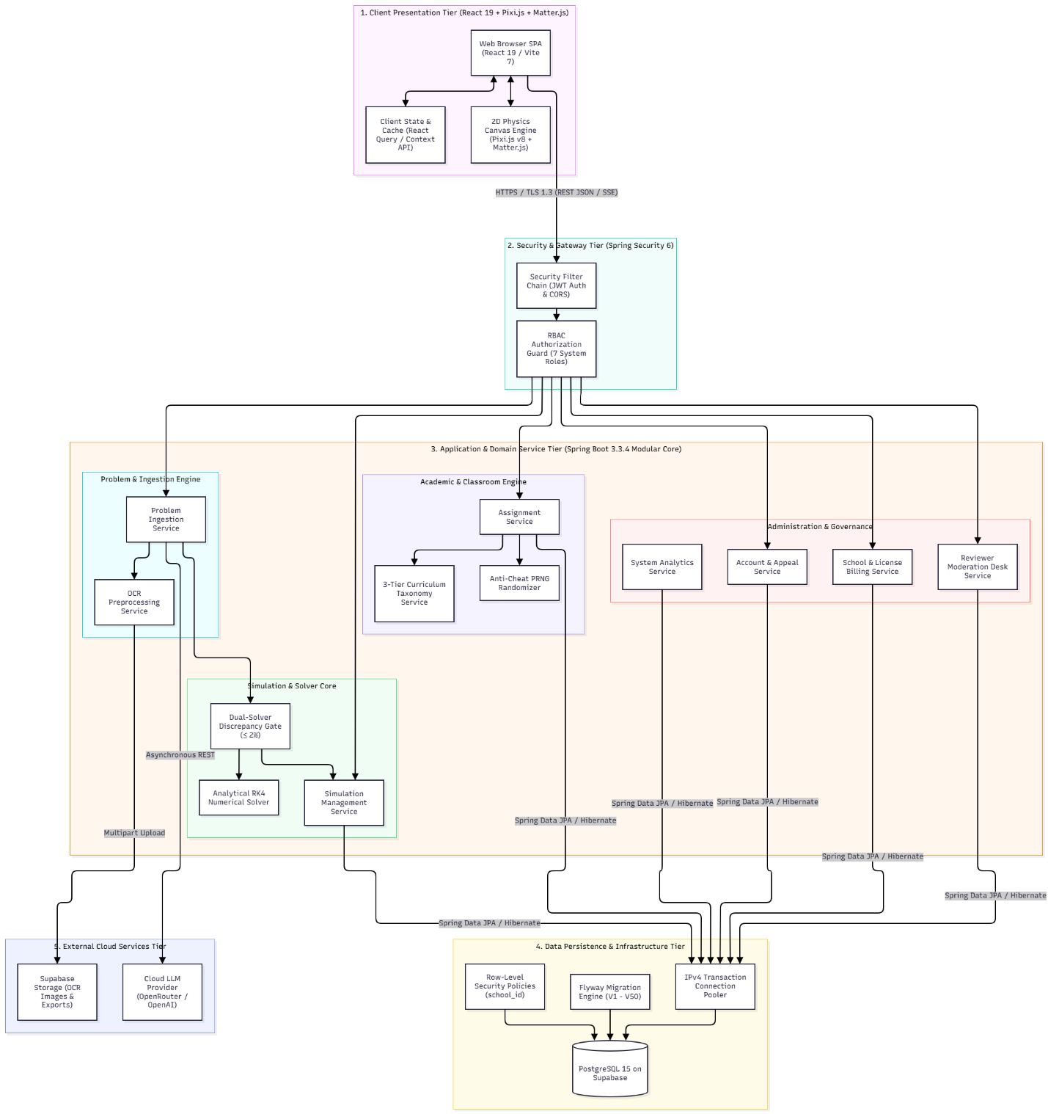
Figure 1. System Architecture Diagram

1.1.3 Subsystem Integration Protocols & Data Flow
- Client-to-Backend Communication:
- Protocol: HTTPS with TLS 1.3 encryption for all network traffic.
- Payload Format: Strict application/json (RFC 8259) using UTF-8 encoding.
- Authentication: Stateless Bearer tokens passed via HTTP Authorization: Bearer headers. Tokens are validated via JwtAuthenticationFilter on every non-public request.
- Streaming: Server-Sent Events (text/event-stream) used for long-running AI problem extraction, providing progressive stage updates (INGEST → EXTRACT → VALIDATE → READY).
- Backend-to-Database Communication:
- Managed via HikariCP connection pooling over encrypted PostgreSQL JDBC sockets (port 5432).
- Multi-tenant school isolation is enforced at query runtime via PostgreSQL session variables (SET LOCAL app.current_school_id = ...) matching database Row-Level Security policies.
- Backend-to-AI Provider Communication:
- Asynchronous HTTP client (WebClient) connecting to cloud LLM inference endpoints.
- Strict timeout policies: Connect timeout 5 seconds, read timeout 25 seconds, with exponential backoff retry (maximum 2 retries).
- Standalone Client Export Execution:
- Exported simulations (FE-06) package the Pixi scene descriptor, physical entity schema, and lightweight Matter.js physics runtime into an immutable, self-contained HTML/JS bundle that executes completely offline in any web browser without server dependencies.

1.2 Package Diagram

1.2.1 Overall Package Architecture
The PhysLive system is divided into two major codebases: the Backend Application Server (com.example.backend) and the Frontend Web Client (react-client/src). Each adheres to clean separation of concerns, ensuring high cohesion and loose coupling.
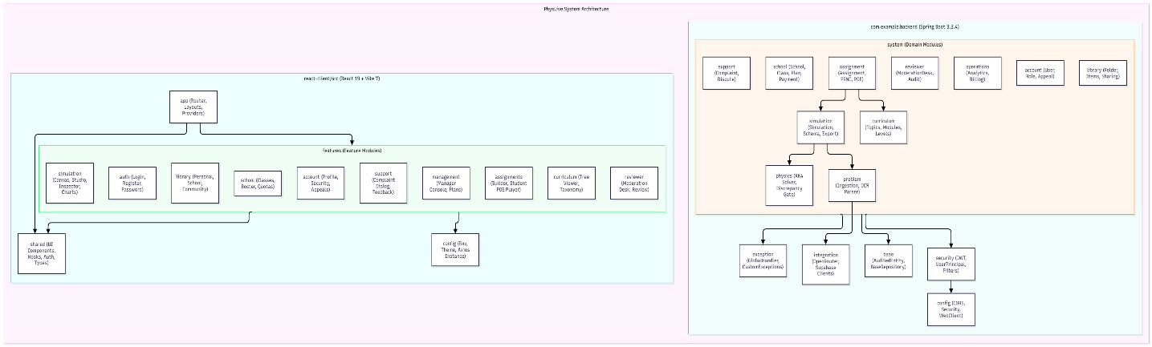
Figure 2. Package Architecture

1.2.2 Package Descriptions
No | Package | Description
01 | com.example.backend.config | Centralized application configuration beans, including CORS policies, Security filter chains, WebClient timeouts, and Jackson JSON serializers.
02 | com.example.backend.security | Implements stateless JWT authentication, Bearer token extraction, HMAC-SHA256 signature verification, and Spring Security UserDetails adapters.
03 | com.example.backend.base | Base abstract classes providing audit timestamping (createdAt, updatedAt), UUID generation, and common repository abstractions.
04 | com.example.backend.exception | Global exception interceptor translating domain exceptions into standard RFC 7807 problem details with localized Vietnamese messages.
05 | com.example.backend.integration | Outbound HTTP client adapters communicating with external Cloud AI providers (OpenRouter) and cloud asset storage (Supabase).
06 | com.example.backend.system.account | User account management, credential authentication, 7-role RBAC enforcement, and 3-tier account suspension/appeal workflows.
07 | com.example.backend.system.school | Multi-tenant school profiles, classroom management, grade rosters, licensing subscription tiers, and transaction logging.
08 | com.example.backend.system.problem | Text ingestion, OCR image preprocessing, formula normalization, and LLM-driven semantic problem parsing into structured physical entities.
09 | com.example.backend.system.physics | Physics law verification engine: executes Runge-Kutta 4th-order (RK4) numerical ODE calculations and cross-checks timeline states against curriculum domain laws.
10 | com.example.backend.system.simulation | Simulation lifecycle management, JSON scene descriptor assembly, parameter constraint controls, and standalone offline export packaging.
11 | com.example.backend.system.assignment | Homework assignment authoring, anti-cheat seeded PRNG parameter randomization per student ID, and automated POE submission grading.
12 | com.example.backend.system.curriculum | Manages the 3-tier curriculum taxonomy hierarchy (K → K01 → K01-10 → K01-10-01), topic indexing, and GDPT 2018 standards alignment.
13 | com.example.backend.system.library | Folder organization for personal teacher simulations, school-wide resource repositories, and community sharing workflows.
14 | com.example.backend.system.reviewer | Content moderation desk for peer reviewers: simulation audit queue, physical accuracy verification, and public publishing approvals.
15 | com.example.backend.system.operations | Operational analytics tracking weekly/monthly post metrics, B2B token quota depletion, and institutional subscription payments.
16 | com.example.backend.system.support | Human-in-the-loop dispute handling: captures simulation discrepancies and calculation complaints submitted by teachers.
17 | react-client/src/features/simulation | Complete interactive simulation suite: 3-pane studio, Pixi.js / Matter.js canvas player, vector overlays, parameter inspector, and live charts.
18 | react-client/src/features/assignments | Teacher assignment builder (3-step wizard with POE questions) and student learning portal with interactive POE prediction player.
19 | react-client/src/features/account | User account profile settings, password modification, administrative user tables, and account suspension appeal dialogs.
20 | react-client/src/features/library | Simulation catalog management: directory tree, multi-tier sharing modal (Private, School, Community), and export actions (HTML, PDF, JSON).
21 | react-client/src/features/reviewer | Dedicated console for Content Reviewers: moderation queue, physical law gap auditing, model verification telemetry inspection, and curation approval forms.
22 | react-client/src/shared | Shared reusable UI components (Radix primitives, Lucide icons), Axios HTTP client interceptors, auth contexts, hooks, and TypeScript types.

2. Database Design

2.1 Database Overview & Physical Architecture
The PhysLive persistence tier is built on PostgreSQL 15 managed through Supabase Cloud infrastructure. The physical schema is engineered to handle relational multi-tenant school governance alongside semi-structured physical simulation schemas and high-throughput real-time telemetry.

Key physical architectural characteristics include:

- Database Schema Versioning: Database migrations are strictly managed using Flyway (Migrations V1 through V50), guaranteeing idempotent, reproducible, and verifiable schema evolution across development, testing, and production environments.
- Multi-Tenant Row-Level Security (RLS): All tenant-specific tables (users, school_classes, class_enrollments, assignments, assignment_submissions, school_payments) are partition-isolated by school_id. PostgreSQL Row-Level Security policies dynamically intercept all SQL queries based on the authenticated session's tenant token (SET LOCAL app.current_school_id = ...), preventing cross-institutional data leakage at the database engine level.
- Primary Key Strategy: Distributed entities utilize cryptographically secure UUID v4 primary keys generated via PostgreSQL's gen_random_uuid() function to prevent sequential enumeration attacks and facilitate seamless offline client caching. Reference entities (roles, permissions, users) utilize sequential INTEGER / BIGINT identifiers optimized for high-frequency join performance.
- Hybrid Relational & Document Persistence (JSONB): Physical quantities, initial kinematic states, simulation boundaries, and student POE prediction vectors are stored as strongly-validated JSONB documents. GIN (Generalized Inverted Index) indexes are deployed on JSONB fields (specifications.quantities, assignment_submissions.predictions) to enable sub-millisecond query evaluation on dynamic nested keys without requiring schema migrations.
- Connection Pooling & Concurrency: Backend instances connect to the database via HikariCP through a dedicated Supabase IPv4 Transaction Pooler (port 5432), supporting up to 100 concurrent transactional connections with a maximum checkout timeout of 10,000 ms.

2.2 Entity Relationship Diagram (ERD)
The diagram below represents the complete physical Entity-Relationship model of the PhysLive platform, illustrating all 20 relational tables, primary keys, foreign key constraints, and cardinalities:
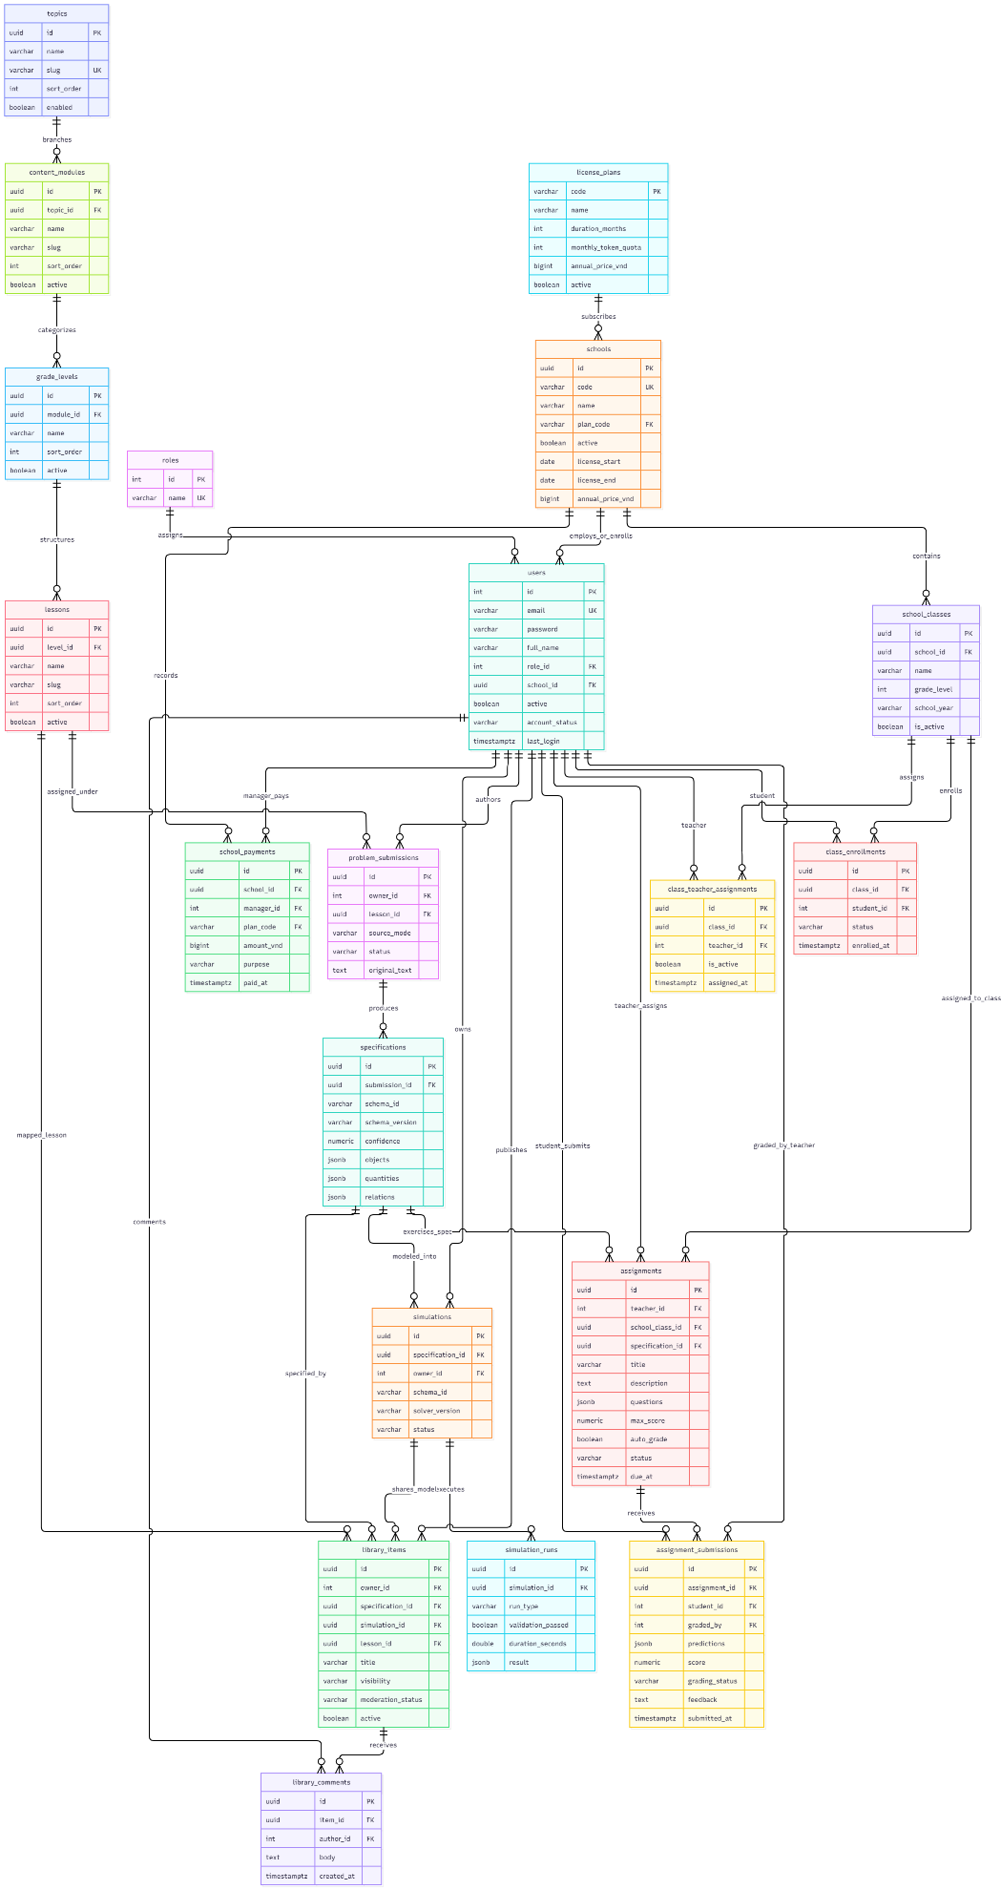
Figure 3. Entity Relationship Diagram

2.3 Detailed Table Descriptions
Table Descriptions
No | Table | Description
01 | roles | System Role Catalog: Stores the 7 standardized Role-Based Access Control (RBAC) role definitions governing platform authorization boundaries.  - Primary keys: id (INT, Auto-increment)  - Foreign keys: None  - Key Attributes: name (VARCHAR(32), NOT NULL, UNIQUE: GUEST, STUDENT, STAFF, SCHOOL, REVIEWER, MANAGER, ADMIN).
02 | users | Master User Accounts: Stores authenticated user identities across all 7 roles, including password hashes, school associations, and 3-tier lifecycle statuses.  - Primary keys: id (INT, Auto-increment)  - Foreign keys: role_id (INT → roles.id), school_id (UUID → schools.id, NULL for platform roles)  - Key Attributes: email (VARCHAR(255), NOT NULL, UNIQUE), password (VARCHAR(255), BCrypt hash), full_name (VARCHAR(150)), active (BOOLEAN, default TRUE), account_status (VARCHAR(32): ACTIVE, WARNED, SUSPENDED_READ_ONLY), last_login (TIMESTAMPTZ).
03 | user_permissions | Granular User Permissions: Assigns specific operational permission overrides to individual users beyond their base role (e.g., CONTENT_EDIT, CONTENT_REVIEW).  - Primary keys: id (INT, Auto-increment)  - Foreign keys: user_id (INT → users.id ON DELETE CASCADE)  - Key Attributes: permission_code (VARCHAR(64), NOT NULL), granted_at (TIMESTAMPTZ, default NOW()), granted_by (INT → users.id).
04 | account_appeals | Account Suspension Appeals: Records dispute tickets submitted by users placed under SUSPENDED_READ_ONLY status requesting administrative review.  - Primary keys: id (UUID, default gen_random_uuid())  - Foreign keys: user_id (INT → users.id), reviewed_by (INT → users.id, NULL)  - Key Attributes: reason (VARCHAR(100), NOT NULL), appeal_details (TEXT, NOT NULL), status (VARCHAR(32): PENDING, APPROVED, REJECTED), reviewed_at (TIMESTAMPTZ), created_at (TIMESTAMPTZ).
05 | schools | Institutional Tenants: Stores high-school institutional profiles, subscription contracts, annual licensing periods, and multi-tenant partition bounds.  - Primary keys: id (UUID, default gen_random_uuid())  - Foreign keys: plan_code (VARCHAR(32) → license_plans.code)  - Key Attributes: code (VARCHAR(50), NOT NULL, UNIQUE), name (VARCHAR(255), NOT NULL), active (BOOLEAN, default TRUE), license_start (DATE), license_end (DATE), annual_price_vnd (BIGINT, default 0).
06 | license_plans | B2B Licensing Plans: Defines commercial institutional tiers (Standard, Pro, Enterprise) detailing monthly token quotas, seat allowances, and pricing.  - Primary keys: code (VARCHAR(32), PK)  - Foreign keys: None  - Key Attributes: name (VARCHAR(100), NOT NULL), duration_months (INT, default 12), monthly_token_quota (INT, default 50000), annual_price_vnd (BIGINT, NOT NULL), active (BOOLEAN, default TRUE).
07 | school_payments | Billing & Subscription Transactions: Tracks financial invoicing and B2B payment transactions submitted by schools or recorded by platform managers.  - Primary keys: id (UUID, default gen_random_uuid())  - Foreign keys: school_id (UUID → schools.id), manager_id (INT → users.id), plan_code (VARCHAR(32) → license_plans.code)  - Key Attributes: amount_vnd (BIGINT, NOT NULL), status (VARCHAR(32): PAID, PENDING, FAILED), purpose (VARCHAR(255)), paid_at (TIMESTAMPTZ), created_at (TIMESTAMPTZ).
08 | school_classes | Classroom Units: Represents individual academic classes (e.g., "10A1", "11 Lý") within a specific school, scoped by academic school year and grade level.  - Primary keys: id (UUID, default gen_random_uuid())  - Foreign keys: school_id (UUID → schools.id ON DELETE CASCADE)  - Key Attributes: name (VARCHAR(100), NOT NULL), grade_level (INT, CHECK between 10 and 12), school_year (VARCHAR(20): "2026-2027"), is_active (BOOLEAN, default TRUE).
09 | class_enrollments | Student Class Memberships: Many-to-many junction associating enrolled students with their corresponding academic classrooms.  - Primary keys: id (UUID, default gen_random_uuid())  - Foreign keys: class_id (UUID → school_classes.id), student_id (INT → users.id)  - Key Attributes: status (VARCHAR(32): ENROLLED, DROPPED, COMPLETED), enrolled_at (TIMESTAMPTZ, default NOW()), UNIQUE constraint (class_id, student_id).
10 | class_teacher_assignments | Classroom Teacher Staffing: Associates subject teachers with classrooms for assignment distribution and academic supervision rights.  - Primary keys: id (UUID, default gen_random_uuid())  - Foreign keys: class_id (UUID → school_classes.id), teacher_id (INT → users.id)  - Key Attributes: is_active (BOOLEAN, default TRUE), assigned_at (TIMESTAMPTZ, default NOW()), UNIQUE constraint (class_id, teacher_id).
11 | topics (curriculum_topics) | Primary Physics Disciplines: Root curriculum categories conforming to the Vietnam GDPT 2018 Physics framework (Mechanics, Thermodynamics, Electromagnetism, Optics, Nuclear).  - Primary keys: id (UUID, default gen_random_uuid())  - Foreign keys: None  - Key Attributes: name (VARCHAR(150), NOT NULL), slug (VARCHAR(100), NOT NULL, UNIQUE), sort_order (INT, default 0), enabled (BOOLEAN, default TRUE).
12 | content_modules | Curriculum Sub-Modules: Second-level hierarchy representing specific physical subject units (e.g., Kinematics, Dynamics, DC Circuits, Wave Optics).  - Primary keys: id (UUID, default gen_random_uuid())  - Foreign keys: topic_id (UUID → topics.id ON DELETE CASCADE)  - Key Attributes: name (VARCHAR(150), NOT NULL), slug (VARCHAR(100), NOT NULL), sort_order (INT, default 0), active (BOOLEAN, default TRUE).
13 | grade_levels | Academic Grade Strata: Categorizes modules across national high-school levels (Grade 10, Grade 11, Grade 12) according to educational depth.  - Primary keys: id (UUID, default gen_random_uuid())  - Foreign keys: module_id (UUID → content_modules.id ON DELETE CASCADE)  - Key Attributes: name (VARCHAR(50): "Lớp 10", "Lớp 11", "Lớp 12"), sort_order (INT, default 0), active (BOOLEAN, default TRUE).
14 | lessons | Specific Curriculum Lessons: Leaf-node learning objectives identified by standardized hierarchical curriculum codes (e.g., K01-10-01).  - Primary keys: id (UUID, default gen_random_uuid())  - Foreign keys: level_id (UUID → grade_levels.id ON DELETE CASCADE)  - Key Attributes: name (VARCHAR(255), NOT NULL), lesson_code (VARCHAR(50), NOT NULL, UNIQUE), slug (VARCHAR(150)), sort_order (INT), active (BOOLEAN, default TRUE).
15 | problem_submissions | Problem Ingestion Records: Captures raw physics problem text, OCR upload provenance, and AI parsing lifecycle state.  - Primary keys: id (UUID, default gen_random_uuid())  - Foreign keys: owner_id (INT → users.id), lesson_id (UUID → lessons.id, NULL)  - Key Attributes: source_mode (VARCHAR(32): TEXT, IMAGE_OCR), status (VARCHAR(32): PENDING, EXTRACTED, FAILED), original_text (TEXT, NOT NULL), created_at (TIMESTAMPTZ).
16 | specifications | Physical Entity Schemas: Stores semi-structured physical entities, extracted quantities, SI units, boundary conditions, and confidence scores parsed by LLM.  - Primary keys: id (UUID, default gen_random_uuid())  - Foreign keys: submission_id (UUID → problem_submissions.id ON DELETE CASCADE)  - Key Attributes: schema_id (VARCHAR(64)), schema_version (VARCHAR(16)), confidence (NUMERIC(5,4)), quantities (JSONB, GIN indexed), relations (JSONB), objects (JSONB).
17 | simulations | Verified Simulation Models: Represents generated 2D simulation packages ready for canvas playback, containing numerical equations and scene templates.  - Primary keys: id (UUID, default gen_random_uuid())  - Foreign keys: specification_id (UUID → specifications.id), owner_id (INT → users.id)  - Key Attributes: schema_id (VARCHAR(64)), solver_version (VARCHAR(32): "RK4-2.1"), status (VARCHAR(32): DRAFT, VALIDATED, REJECTED), created_at (TIMESTAMPTZ).
18 | simulation_runs & simulation_complaints | Execution Audits & Physical Law Telemetry: Records simulation verification run telemetry (law check statuses: VERIFIED, PARTLY_VERIFIED, FLAGGED) and teacher feedback complaint tickets.  - Primary keys: id (UUID, default gen_random_uuid())  - Foreign keys: simulation_id (UUID → simulations.id), teacher_id (INT → users.id)  - Key Attributes: run_type (VARCHAR(32)), validation_passed (BOOLEAN), issue_type (VARCHAR(64): "Calculation Error", "Missing Law"), description (TEXT), status (VARCHAR(32): OPEN, RESOLVED).
19 | library_items & library_folders | Shared Simulation Catalog & Tree: Organizes saved simulations into hierarchical personal folders and manages multi-tier sharing visibility.  - Primary keys: id (UUID, default gen_random_uuid())  - Foreign keys: owner_id (INT → users.id), simulation_id (UUID → simulations.id), parent_id (UUID → library_folders.id)  - Key Attributes: title (VARCHAR(200)), visibility (VARCHAR(32): PRIVATE, SCHOOL, PUBLIC), moderation_status (VARCHAR(32): PENDING, APPROVED, REJECTED), active (BOOLEAN).
20 | assignments & assignment_submissions | Homework Tasks & POE Submissions: Homework packages with POE questions, anti-cheat PRNG parameter seeds, and auto-graded student predictions.  - Primary keys: id (UUID, default gen_random_uuid())  - Foreign keys: teacher_id (INT → users.id), school_class_id (UUID → school_classes.id), assignment_id (UUID → assignments.id), student_id (INT → users.id)  - Key Attributes: assigned_parameters (JSONB, seeded per student ID), predictions (JSONB, student POE answers), score (NUMERIC(5,2)), grading_status (VARCHAR(32): SUBMITTED, GRADED), due_at (TIMESTAMPTZ).

3. Detailed Design

3.1 Problem Ingestion & Physics Verification Engine (FE-01, FE-02, FE-03, FE-04)
This subsystem encompasses the ingestion of physics problems via raw text typing or OCR image uploads, AI-driven entity parsing and unit verification, independent Runge-Kutta numerical solving, domain physics law verification against curriculum law invariants (assigning Verified, Partly Verified, Illustrative, or Flagged statuses with self-repair loops), and human-in-the-loop parameter ambiguity resolution.

3.1.1 Class Diagram
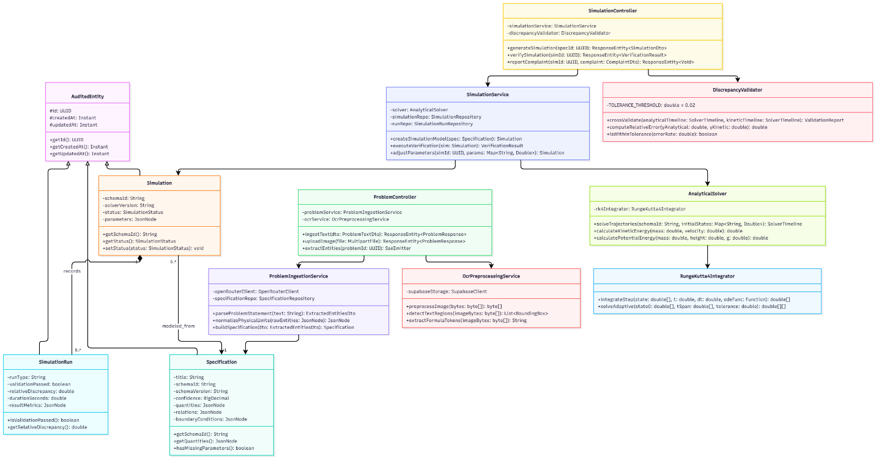

3.1.2 Class Specifications
The following table provides detailed structural and operational specifications for the classes comprising the Problem Ingestion & Physics Verification Engine:
Class Name | Attributes | Methods | Description & Responsibilities
ProblemController | - problemService: ProblemIngestionService  - ocrService: OcrPreprocessingService | + ingestText(dto: ProblemTextDto): ResponseEntity  + uploadImage(file: MultipartFile): ResponseEntity  + extractEntities(problemId: UUID): SseEmitter | REST controller exposing endpoints for problem text submission, OCR image upload, and Server-Sent Event streaming for multi-stage problem extraction.
ProblemIngestionService | - openRouterClient: OpenRouterClient  - specificationRepo: SpecificationRepository | + parseProblemStatement(text: String): ExtractedEntitiesDto  + normalizePhysicalUnits(rawEntities: JsonNode): JsonNode  + buildSpecification(dto: ExtractedEntitiesDto): Specification | Core domain service communicating with Cloud LLM via OpenRouter, applying dimensional analysis to convert non-SI units, and persisting physical specifications.
OcrPreprocessingService | - supabaseStorage: SupabaseClient | + preprocessImage(bytes: byte[]): byte[]  + detectTextRegions(imageBytes: byte[]): List  + extractFormulaTokens(imageBytes: byte[]): String | Performs image contrast enhancement, binarization, bounding-box detection, and formula token extraction prior to cloud OCR ingestion.
Specification | - title: String  - schemaId: String  - schemaVersion: String  - confidence: BigDecimal  - quantities: JsonNode  - relations: JsonNode  - boundaryConditions: JsonNode | + getSchemaId(): String  + getQuantities(): JsonNode  + hasMissingParameters(): boolean | Domain entity storing semi-structured physical models, parsed initial conditions, variables, SI units, and LLM semantic confidence scores.
SimulationService | - solver: AnalyticalSolver  - simulationRepo: SimulationRepository  - runRepo: SimulationRunRepository | + createSimulationModel(spec: Specification): Simulation  + executeVerification(sim: Simulation): VerificationResult  + adjustParameters(simId: UUID, params: Map): Simulation | Manages simulation model lifecycle, coordinates Runge-Kutta analytical calculations, and persists simulation runs and parameter overrides.
AnalyticalSolver | - rk4Integrator: RungeKutta4Integrator | + solveTrajectories(schemaId: String, initialStates: Map): SolverTimeline  + calculateKineticEnergy(mass: double, velocity: double): double  + calculatePotentialEnergy(mass: double, height: double, g: double): double | Executes mathematical ODE integrations using Runge-Kutta 4th order algorithms to establish exact ground-truth time series data.
PhysicsLawValidator | - lawCatalogue: JsonNode  - violationThreshold: double | + validateLawInvariants(timeline: SolverTimeline, catalogue: JsonNode): ValidationReport  + checkConservationLaws(state: TimeStepState): LawCheckResult  + isCompliant(report: ValidationReport): boolean | Enforces Business Rule BR-01: evaluates simulation timeline against physical conservation laws (mechanical energy, momentum, Newton's laws) and tags runs as VERIFIED or FLAGGED.
Simulation | - schemaId: String  - solverVersion: String  - status: SimulationStatus  - parameters: JsonNode | + getSchemaId(): String  + getStatus(): SimulationStatus  + setStatus(status: SimulationStatus): void | Domain entity representing a validated simulation package ready for HTML5 canvas execution, containing verified parameter ranges and metadata.

3.1.3 SD-01: Multi-Modal Problem Ingestion & AI Parsing Sequence Diagram
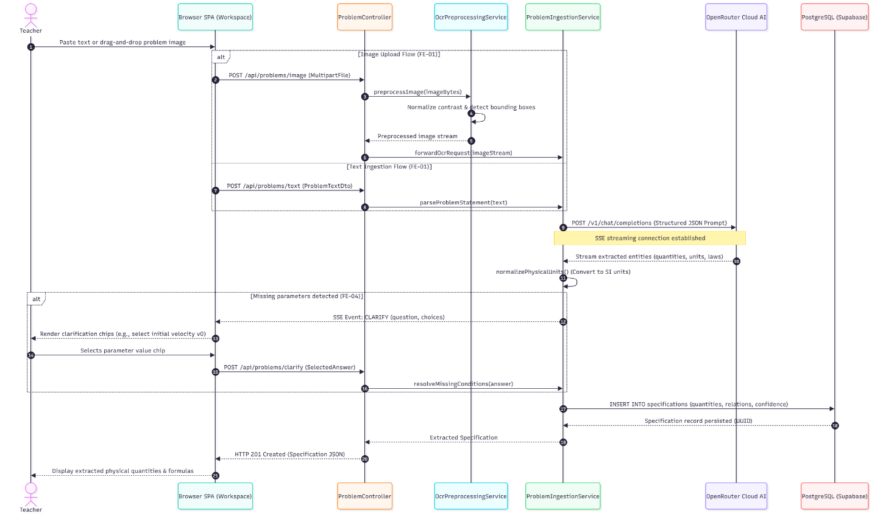

3.1.4 SD-02: Physics Law Verification & Self-Repair Loop Sequence Diagram
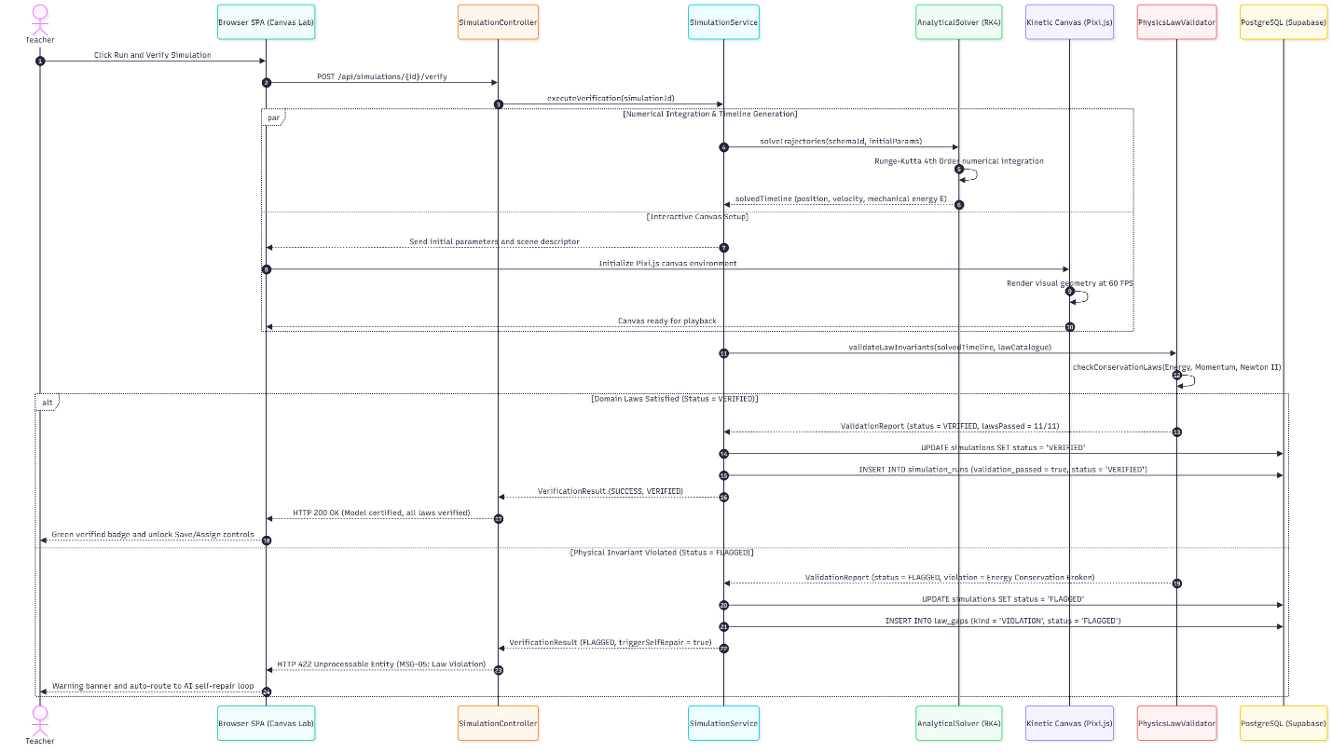

3.2 Interactive Classroom Player & Assessment Engine (FE-05, FE-07, FE-08)
This subsystem handles interactive 2D simulation rendering on HTML5 canvas with real-time vector inspection, teacher assignment authoring with anti-cheat pseudo-random parameter generation, and student Predict-Observe-Explain (POE) assessment execution.

3.2.1 Class Diagram
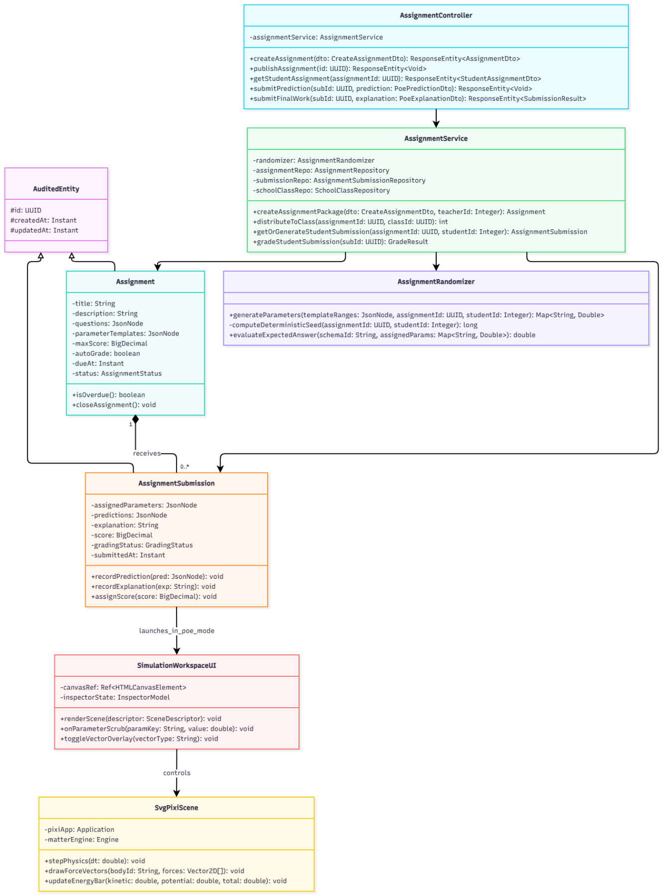

3.2.2 Class Specifications
The following table provides detailed structural specifications for classes supporting interactive classroom simulations and automated POE assessments:
Class Name | Attributes | Methods | Description & Responsibilities
AssignmentController | - assignmentService: AssignmentService | + createAssignment(dto): ResponseEntity  + publishAssignment(id): ResponseEntity  + getStudentAssignment(id): ResponseEntity  + submitPrediction(subId, pred): ResponseEntity  + submitFinalWork(subId, exp): ResponseEntity | Handles HTTP REST endpoints for teacher assignment publishing, class distribution, student POE prediction locking, and final submission scoring.
AssignmentService | - randomizer: AssignmentRandomizer  - assignmentRepo: AssignmentRepository  - submissionRepo: AssignmentSubmissionRepository  - schoolClassRepo: SchoolClassRepository | + createAssignmentPackage(dto, teacherId): Assignment  + distributeToClass(assignmentId, classId): int  + getOrGenerateStudentSubmission(assignmentId, studentId): AssignmentSubmission  + gradeStudentSubmission(subId): GradeResult | Coordinates assignment lifecycle, invokes anti-cheat parameter randomizer, orchestrates student roster distribution, and calculates automated grades against analytical ground truth.
AssignmentRandomizer | None (Stateless Utility) | + generateParameters(templateRanges, assignmentId, studentId): Map  - computeDeterministicSeed(assignmentId, studentId): long  + evaluateExpectedAnswer(schemaId, assignedParams): double | Implements Business Rule BR-02: generates deterministic pseudo-random variable values seeded by hash(assignment_id + student_id) to prevent answer copying.
Assignment | - title: String  - description: String  - questions: JsonNode  - parameterTemplates: JsonNode  - maxScore: BigDecimal  - autoGrade: boolean  - dueAt: Instant  - status: AssignmentStatus | + isOverdue(): boolean  + closeAssignment(): void | Domain entity storing assignment guidelines, target school classes, POE question sets, parameter boundaries, and deadline timestamps.
AssignmentSubmission | - assignedParameters: JsonNode  - predictions: JsonNode  - explanation: String  - score: BigDecimal  - gradingStatus: GradingStatus  - submittedAt: Instant | + recordPrediction(pred: JsonNode): void  + recordExplanation(exp: String): void  + assignScore(score: BigDecimal): void | Represents an individual student's homework submission, storing their unique seeded parameters, pre-simulation hypotheses, observations, and auto-graded marks.
SimulationWorkspaceUI | - canvasRef: Ref  - inspectorState: InspectorModel | + renderScene(descriptor: SceneDescriptor): void  + onParameterScrub(paramKey: String, value: double): void  + toggleVectorOverlay(vectorType: String): void | Top-level React 19 interactive studio component orchestrating 3-pane split views, canvas resize observers, parameter controls, and live telemetry graphs.
SvgPixiScene | - pixiApp: Application  - matterEngine: Engine | + stepPhysics(dt: double): void  + drawForceVectors(bodyId: String, forces: Vector2D[]): void  + updateEnergyBar(kinetic: double, potential: double, total: double): void | Low-level WebGL canvas renderer combining Pixi.js v8 rendering nodes with Matter.js kinetic rigid-body simulations at 60 FPS.

3.2.3 SD-03: Teacher Assignment Creation & Anti-Cheat Parameter Seeding Sequence Diagram
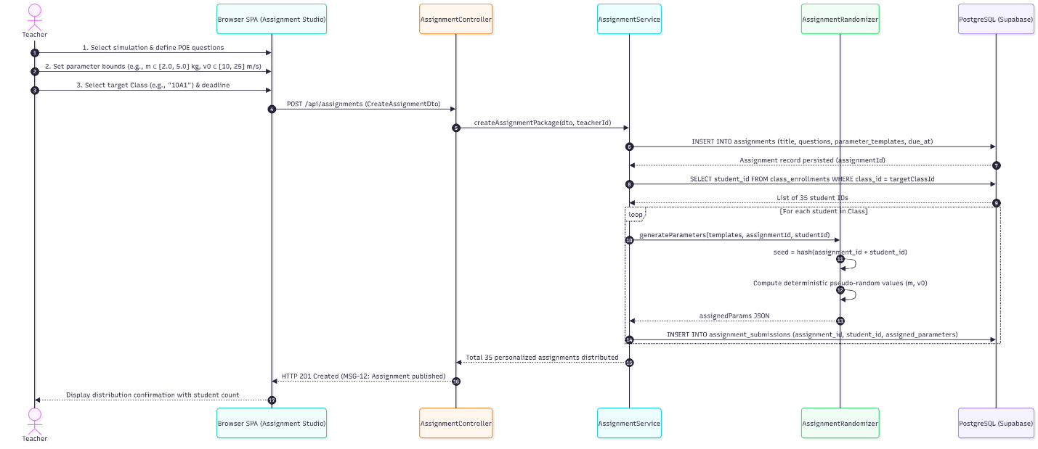

3.2.4 SD-04: Student POE Workflow, Live Canvas Playback & Auto-Grading Sequence Diagram
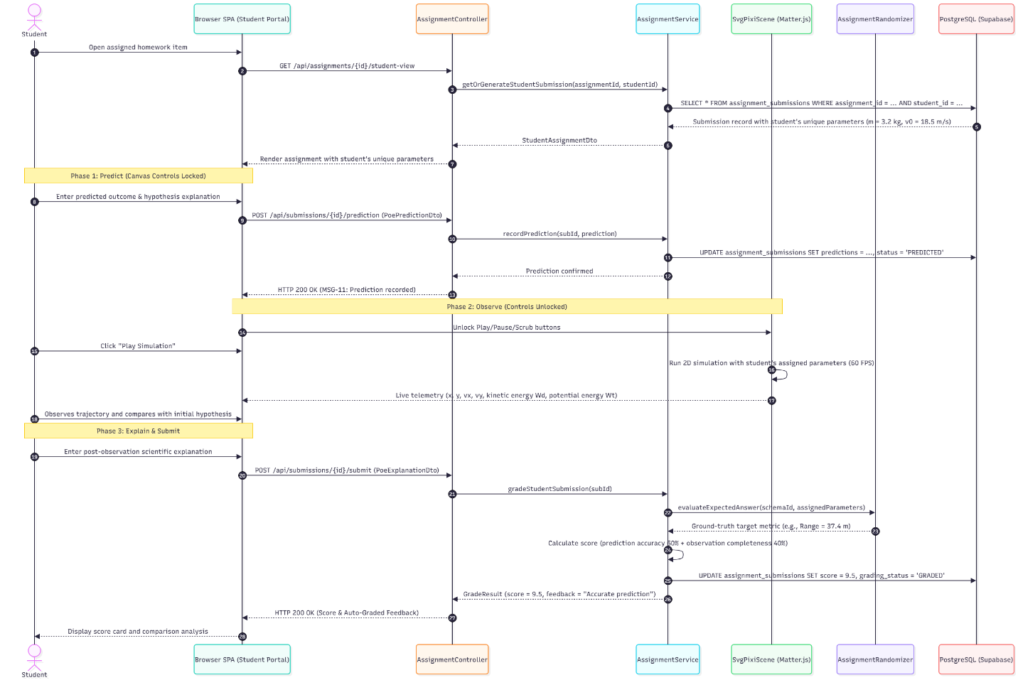

3.3 Multi-Tenant Governance, Moderation & Simulation Export (FE-06, FE-09, FE-10)
This subsystem provides institutional B2B licensing administration, community peer-review moderation queues, PostgreSQL Row-Level Security tenant interception, and self-contained portable simulation bundle exports.

3.3.1 Class Diagram
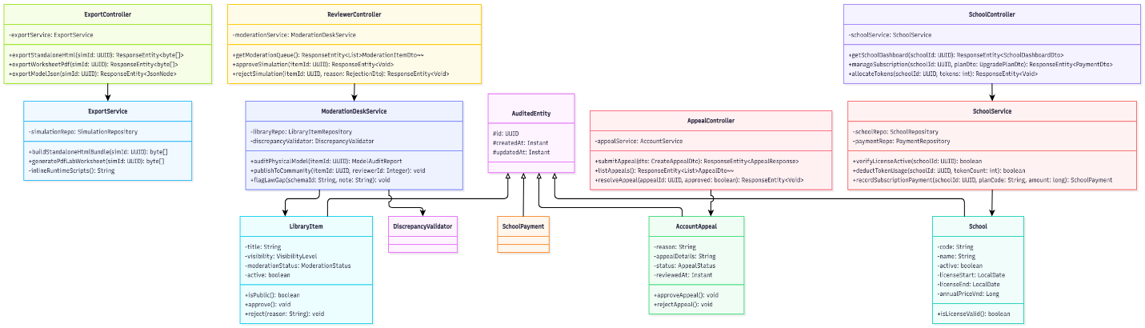

3.3.2 Class Specifications
The following table details the attributes, methods, and responsibilities of the classes governing platform administration, content curation, and simulation exports:
Class Name | Attributes | Methods | Description & Responsibilities
SchoolController | - schoolService: SchoolService | + getSchoolDashboard(id): ResponseEntity  + manageSubscription(id, dto): ResponseEntity  + allocateTokens(id, tokens): ResponseEntity | Administrative endpoints for school tenant executives and platform managers to monitor token pools, license validity, and student enrollments.
SchoolService | - schoolRepo: SchoolRepository  - paymentRepo: PaymentRepository | + verifyLicenseActive(schoolId): boolean  + deductTokenUsage(schoolId, tokens): boolean  + recordSubscriptionPayment(schoolId, plan, amount): SchoolPayment | Business logic for B2B institutional governance, annual licensing renewal, and real-time AI token quota deduction.
ReviewerController | - moderationService: ModerationDeskService | + getModerationQueue(): ResponseEntity  + approveSimulation(id): ResponseEntity  + rejectSimulation(id, reason): ResponseEntity | Moderation endpoints allowing designated Content Reviewers to audit shared simulation submissions and authorize publication to the Community Library.
ModerationDeskService | - libraryRepo: LibraryItemRepository  - lawValidator: PhysicsLawValidator | + auditPhysicalModel(itemId): ModelAuditReport  + publishToCommunity(itemId, reviewerId): void  + flagLawGap(schemaId, note): void | Audits physical formulas, verifies compliance with domain invariant laws, transitions moderation statuses, and records reviewer decisions.
ExportController | - exportService: ExportService | + exportStandaloneHtml(simId): ResponseEntity  + exportWorksheetPdf(simId): ResponseEntity  + exportModelJson(simId): ResponseEntity | Exposes download endpoints delivering standalone offline HTML bundles, PDF lab worksheets, and JSON model descriptors.
ExportService | - simulationRepo: SimulationRepository | + buildStandaloneHtmlBundle(simId): byte[]  + generatePdfLabWorksheet(simId): byte[]  - inlineRuntimeScripts(): String | Bundles simulation scene JSON, Pixi/Matter runtime scripts, and CSS into a self-contained, offline-executable HTML document.
AppealController | - appealService: AccountService | + submitAppeal(dto): ResponseEntity  + listAppeals(): ResponseEntity  + resolveAppeal(id, approved): ResponseEntity | Endpoints supporting 3-tier account suspension governance, allowing suspended users to file formal appeals and managers to review and reinstate accounts.
LibraryItem | - title: String  - visibility: VisibilityLevel  - moderationStatus: ModerationStatus  - active: boolean | + isPublic(): boolean  + approve(): void  + reject(reason: String): void | Domain entity storing catalogued simulations with visibility scopes (PRIVATE, SCHOOL, PUBLIC) and moderation audit histories.

3.3.3 SD-05: Simulation Sharing & Reviewer Moderation Workflow Sequence Diagram
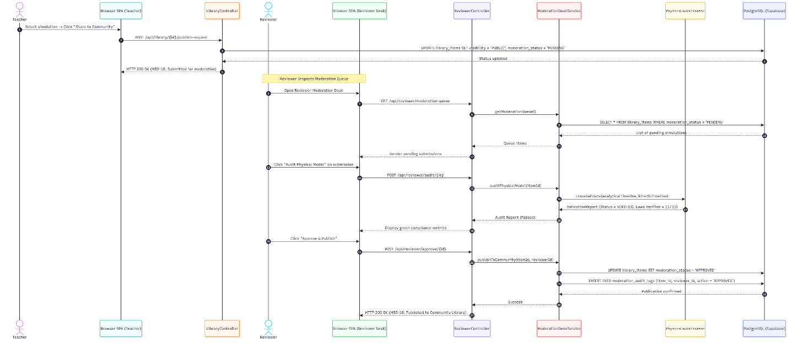

3.3.4 SD-06: Standalone Simulation Bundle Export & Account Suspension Appeal Sequence Diagram


